**Computer vision – HW6**

# Source code

|  |
| --- |
| # WeiWen Wu 2023-10-18  **from** numpy **import** float32**,**ones  **import** cv2 **as** cv  **from** matplotlib **import** pyplot **as** plt  **class** **plot_from_matplotlib:**  """  Make pictures from matplotlib.  # Example  ```  plot = plot_from_matplotlib("title")  plot("Original",img)  plot_from_matplotlib.show()  ```  """  n**:int=**1  **def** __init__**(**self**,**name**:str)** **->** **None:**  fig **=** plt**.**figure**()**  fig**.**canvas**.**manager**.**window**.**setWindowTitle**(**name**)**    **def** __call__**(**self**,**name**:str,**dst**,**cmap**:str=**'gray'**,**save**:bool=**1**):** # Make pictures.  n **=** self**.**n  path **=** __file__**.**split**(**"\\"**)[-**2**]**  plt**.**subplot**(**2**,**3**,**n**),** plt**.**imshow**(**dst**,**cmap**),** plt**.**title**(**name**)**  plt**.**xticks**([]),** plt**.**yticks**([])** # Do not show scale.  **if** save**:** cv**.**imwrite**(**f"./{path}/{name}.png"**,**dst**,[int(**cv**.**IMWRITE_PNG_COMPRESSION**),**0**])**  self**.**n**+=**1  *@staticmethod*  **def** show**():**  plt**.**show**()**  **def** remove_noise**(**img_file**:str):**  plot **=** plot_from_matplotlib**(**img_file**.**split**(**"."**)[**0**])**  img **=** cv**.**imread**(**img_file**)**  ### Plot original image. ###  plot**(**"Original"**,**img**)**  ### Filter2D ###  # Define the kernel, using a N×N NumPy array, where N is odd.  kernel **=** ones**((**3**,** 3**),** float32**)/**9  dst **=** cv**.**filter2D**(**img**,** **-**1**,** kernel**)**  plot**(**"Filter2D"**,**dst**)**  ### Blur ###  img_blur **=** cv**.**blur**(**img**,** **(**3**,** 3**))**  plot**(**"Blur"**,**img_blur**)**  ### GaussianBlur ###  img_GaussianBlur **=** cv**.**GaussianBlur**(**img**,** **(**3**,** 3**),**0**)**  plot**(**"GaussianBlur"**,**img_GaussianBlur**)**  ### Median Filtering ###  img_medianBlur **=** cv**.**medianBlur**(**img**,** 3**)**  plot**(**"Median Filtering"**,**img_medianBlur**)**  ### Bilateral Filtering ###  img_bilateralFilter **=** cv**.**bilateralFilter**(**img**,**15**,** 75**,** 75**)**  plot**(**"Bilateral Filtering"**,**img_bilateralFilter**)**  # remove_noise('lena_noise2.jpg')  remove_noise**(**'lena_noise3.jpg'**)**  ### Show matplotlib. ###  plot_from_matplotlib**.**show**()** |

# Result map

從下圖來看，使用中值濾波器(Median filter)效果較好。

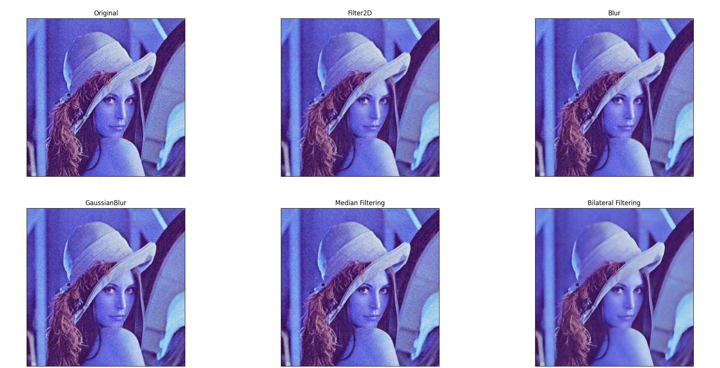

Figure 1 lena_noise2

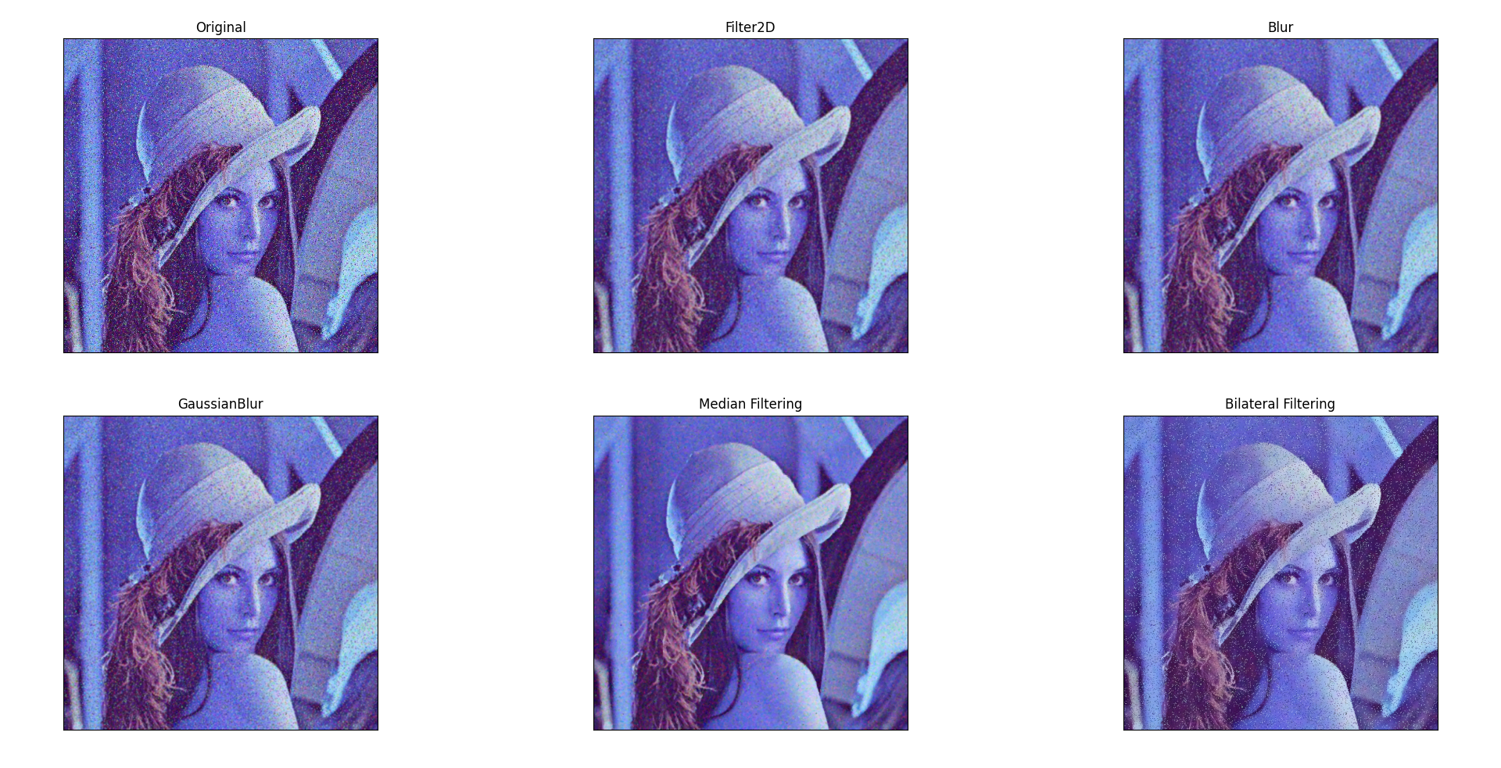

Figure 2 lena_noise3

# Appendix (original picture)

## lena_noise2

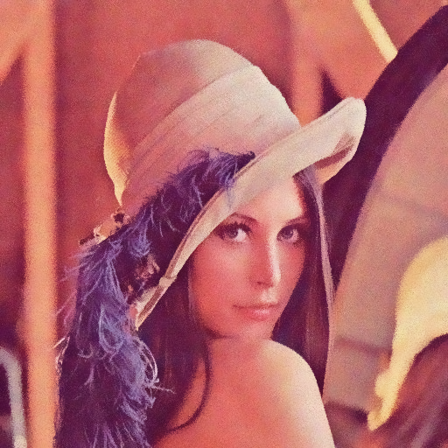

Figure 3 Bilateral Filtering

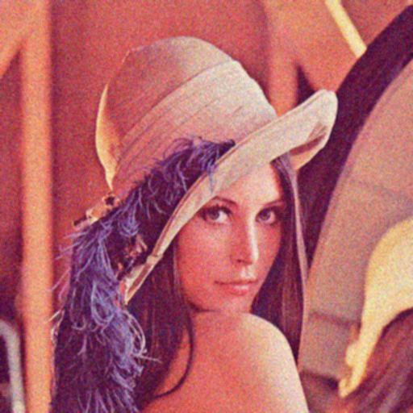

Figure 4 Blur



Figure 5 Filter2D

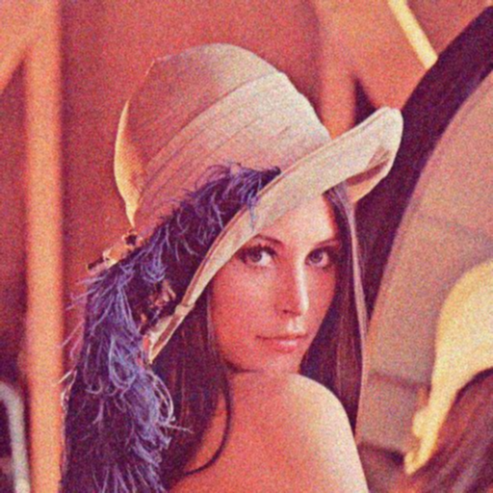

Figure 6 GaussianBlur

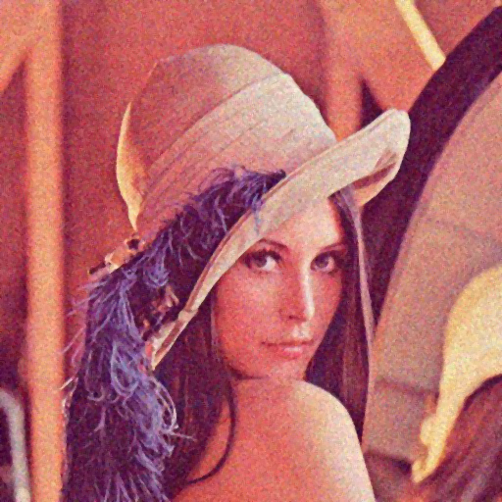

Figure 7 Median Filtering

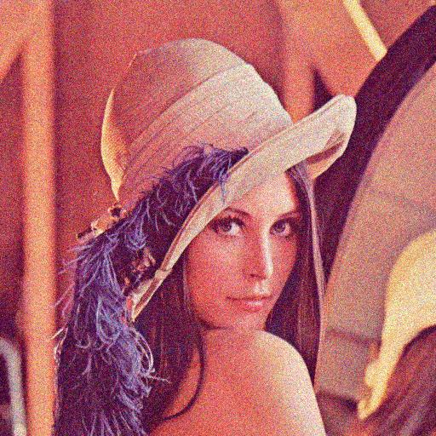

Figure 8 Original

## lena_noise3

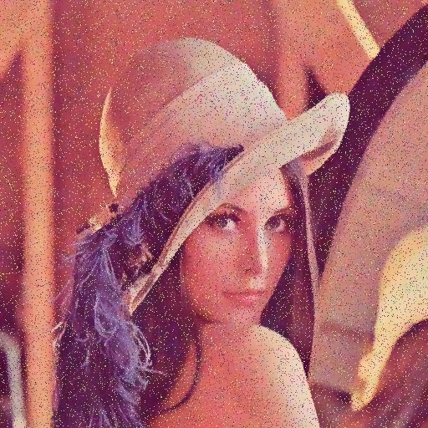

Figure 3 Bilateral Filtering

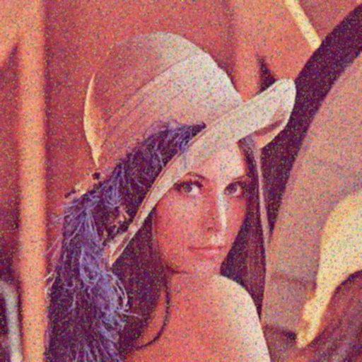

Figure 4 Blur



Figure 5 Filter2D

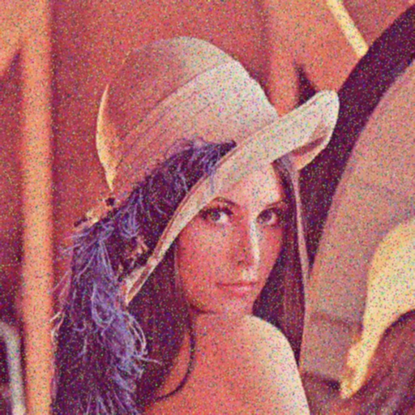

Figure 6 GaussianBlur

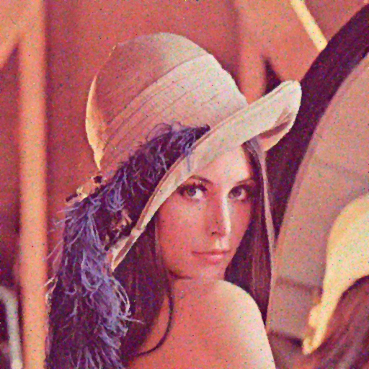

Figure 7 Median Filtering

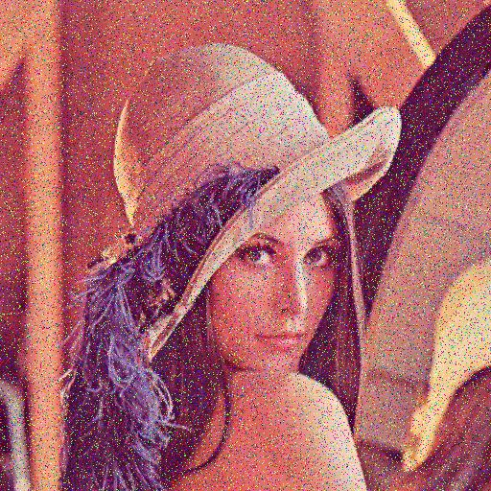

Figure 8 Original